Student Notes are notes that faculty, staff, and administrators can add to student records that allow for internal documentation. These notes do not print on a transcript. Notes can be edited and deleted, as needed, depending on security access level. By default, students cannot view Student Notes on their record; however, note creators can adjust this setting to allow students to view notes on their account. Student notes may be released to students in the event of a subpoena or FERPA request regardless of whether the note was initially shared with the student.

Student notes are valuable records to chronicle a student’s journey at the institution as students work with their advisors. It’s an opportunity to mark their timeline with unique events related to financial aid, registrar/registration, academic advising.

The modification or creation of student notes is attached to specific security groups. If some groups or individuals are having difficulty creating or modifying student notes, it is likely a security problem.

Use this reference to add a Student Note and to understand Student Note Topics security issues.

This guide covers the following:

How to Add Student Note 1
Trouble-shooting Student Note Security 4

How to Add Student Note

- Log into Workday. Navigate to the search bar and type “Student: [Student First Name] [Student Last Name]”. Then, select the student once it populates.

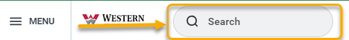

- From the left-hand menu, click “Actions”.

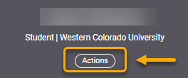

- Click the “Note” and “Add Student Note”.

.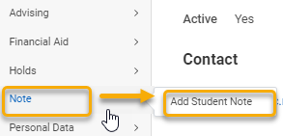

- Complete required fields. Refer to the field descriptions below for details.

When complete, click “OK”.

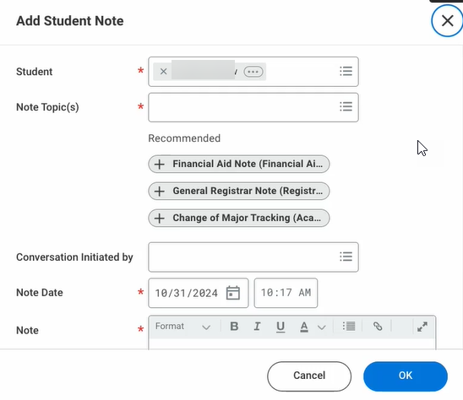

Read below for a description of each field.

New Topic: Options may vary. Select the option that is the best fit. Note topics may be customized and used as tools for categorizing students and in reporting certain unique events. Alternatively, they can serve as a helpful record of events for an individual advisor who is working closely with a student.

Conversation Initiated By: This is not a required field.

Note Date: This will default to today’s date.

Note: The content may not be confidential. Depending on the institution’s policies, these notes may be eligible for a subpoena or included in a student’s FERPA request.

Share with Student: There is the option to allow a note to be visible to students. This field will default to “No”.

If set to “Yes”, the note will appear in the student’s interface. If a situation arises where an advisor and student both want to regularly view notes, the student’s dashboard can be customized to provide easy access.

Academic Period: Notes can be attached to certain academic periods, which may be helpful in reporting. This field is not required.

Relates to: This field is optional. It allows the note to be attached to the student’s academic record. This may be applicable if the note relates to academics and student has more than one academic record. The user may select the academic record that relates to the note.

- After clicking “OK”, the Add Student Note page will appear. You have the option to finish the task by clicking “Done” or Add Linked Note.

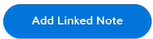



A linked note is an additional note form that will be separate, but attached to the initial note. This is the form.
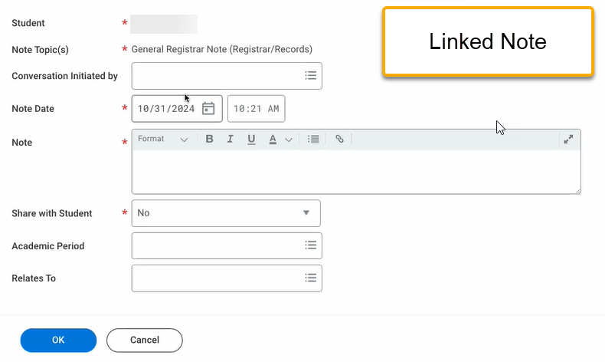

Trouble-shooting Student Note Security

In order to add a Student Note Topic to the Note Topic drop-down field in the Student Note form, the new note topic must be created and then attached to a security segment. Additionally, users must belong to the approved security group in order to view the drop-down option.

If you create a new note topic and it is not visible, review the following pages to troubleshoot the problem. It will likely be a problem with 1) the security group, 2) domain security policy, or 3) the user is not authorized. We will review all three.

In this example, I created a new Student Note Topic called Immunization Notes and it is attached to the Immunization Student Notes Segment. However, the note topic does not appear on the Student Notes form for a particular individual.

On the View Student Note Security Segments page, I can confirm that the note is indeed attached properly to the security segment.

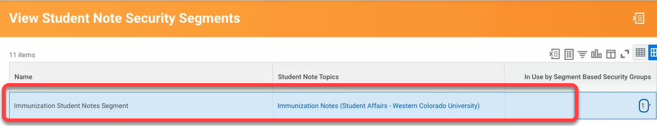

On the View Segment-Based Security Group page, I can confirm the Immunization Student Notes Segment and the attached security group, Student Affairs – High Level. This means those in the Student Affairs – High Level security group should have access to this student note segment.

Additionally, this table shows that the Student Affairs – High Level security group should be able to view and modify this note.

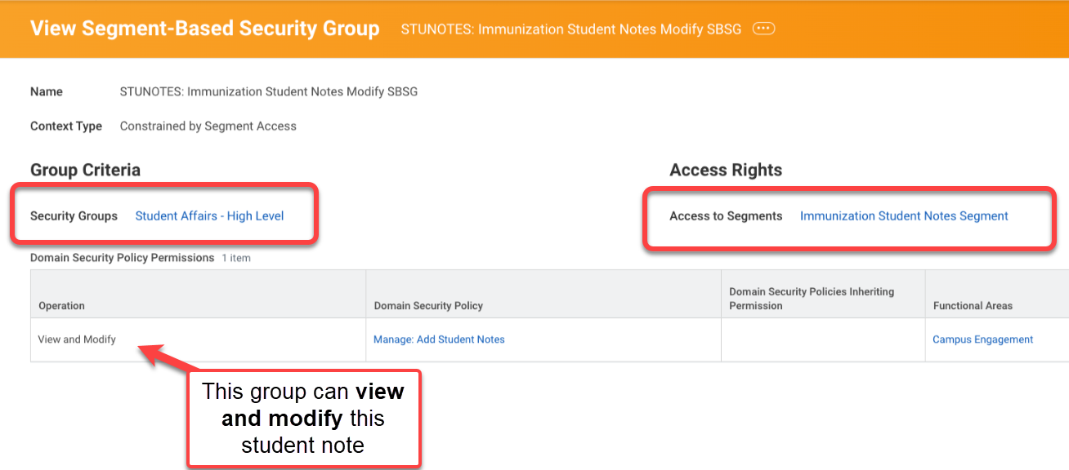

The View Domain Security Policy page confirms this to be true.

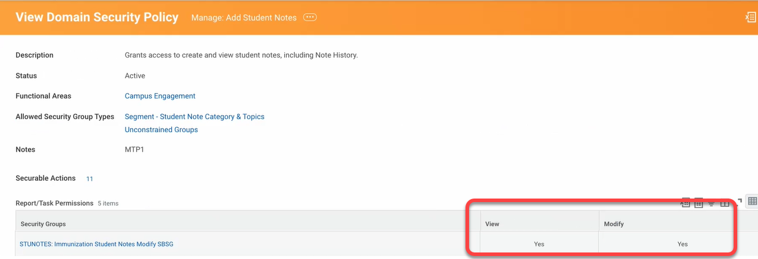

At this point, the note topic and the attached security groups look good. So, next I will take a closer look at the Student Affairs – High Level security group followed by a closer look at the individual user who should have access.

To do this, go to the Western Colorado University Academic Unit page, click related actions, select “Roles” and select “Assign Roles”.

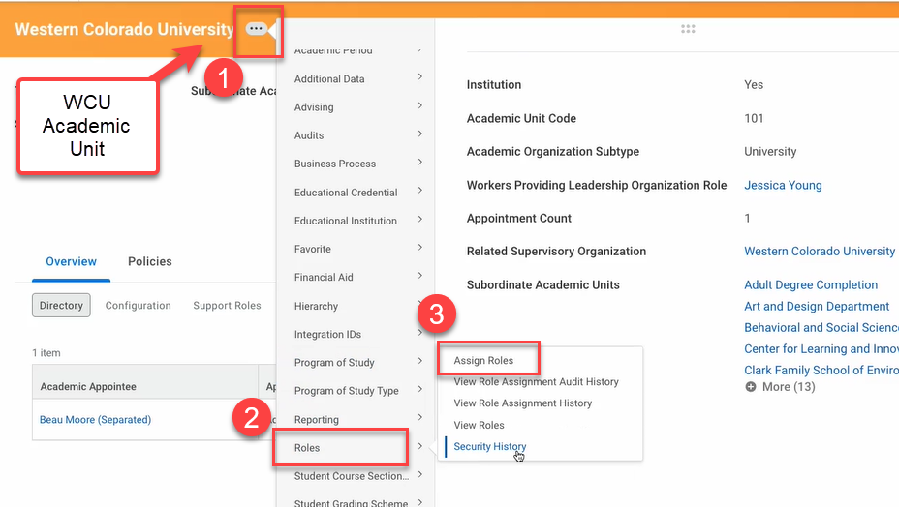

On the Assign Roles page, locate Student Affairs – High Level in the Roles column. You may use the filter to do this.

When the Student Affairs – High Level assignment is displayed, I can see that the individual who was not able to see the note topic were not assigned to this role.

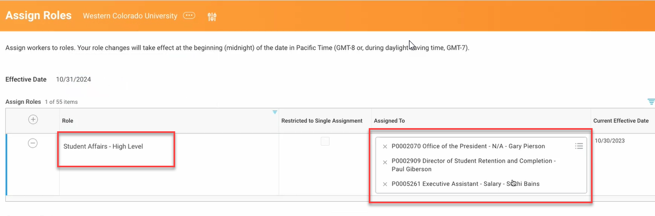

This individual is a report writer and should be included in the Student Affairs – High Level role, so I will add them now. To add, click the field in the “Assigned To” column and add.

When finished, click “OK”. Click “Done”.

At this point, I will review the View Security for Securable Item task. This is a good way to find how an item is being secured.

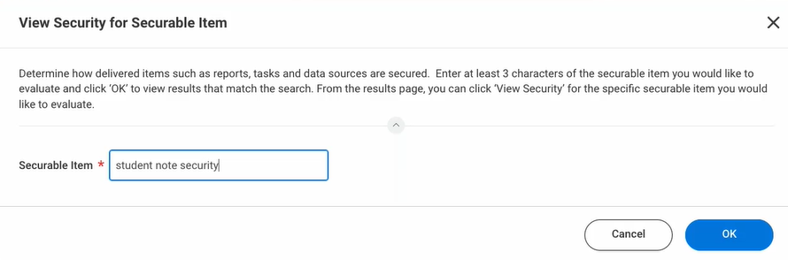

Through this window, I found the Edit Student Note Security Segment task and found it was missing several security groups. The missing groups were added to prevent this problem from reoccurring.

